SET 30: MOBILE APP USAGE ANALYSIS
Aim
To analyze mobile app usage data using R programming by creating a histogram, density plot, scatter plot, and bar chart, and to design a mini dashboard in Tableau.
Dataset
The dataset Mobile_App_Usage.csv contains User_ID, Gender, Age, Screen_Time (hrs), App_Usage_Count, Data_Used (GB), Satisfaction, and Usage_Date.
R Code – Create Dataset
mobile <- data.frame(
User_ID = c("U01", "U02", "U03", "U04", "U05", "U06"),
Gender = c("Male", "Female", "Male", "Female", "Male", "Female"),
Age = c(20, 22, 19, 21, 23, 20),
Screen_Time = c(4.5, 6.0, 3.2, 7.1, 2.8, 5.4),
App_Usage_Count = c(18, 25, 12, 30, 10, 22),
Data_Used = c(2.4, 3.8, 1.6, 4.5, 1.2, 3.1),
Satisfaction = c(3, 5, 3, 5, 2, 4),
Usage_Date = c("2025-01-08", "2025-01-08", "2025-02-11",
"2025-02-11", "2025-03-14", "2025-03-14")
)
write.csv(mobile, "Mobile_App_Usage.csv", row.names = FALSE)
Question 1: Plot a Histogram and Density Plot for Screen Time
R Code
library(ggplot2)

mobile <- read.csv("Mobile_App_Usage.csv")
mobile

ggplot(mobile, aes(x = Screen_Time)) +
geom_histogram(aes(y = after_stat(density)), bins = 5,
fill = "skyblue", color = "white") +
geom_density(color = "red", linewidth = 1) +
labs(
title = "Histogram and Density Plot of Screen Time",
x = "Screen Time (hrs)",
y = "Density"
)

summary(mobile$Screen_Time)
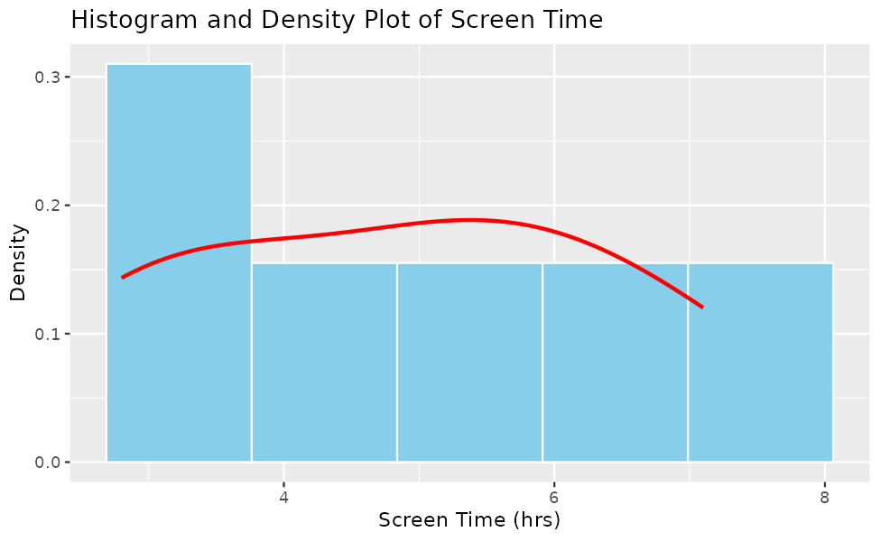
Result
The screen time ranges from 2.8 to 7.1 hours, with a mean of 4.83 hours and a median of 4.95 hours. The first quartile is 3.53 hours and the third quartile is 5.85 hours.
The distribution is spread widely with no extreme values. Most users spend between 3 and 6 hours on their mobile apps each day, and a few heavy users spend more than 7 hours.

Question 2: Create a Scatter Plot Between Data Used and Screen Time
R Code
correlation <- cor(mobile$Data_Used, mobile$Screen_Time)
correlation

ggplot(mobile, aes(x = Data_Used, y = Screen_Time)) +
geom_point(size = 3, color = "blue") +
geom_smooth(method = "lm", se = FALSE, color = "red") +
labs(
title = "Data Used vs Screen Time",
x = "Data Used (GB)",
y = "Screen Time (hrs)"
)
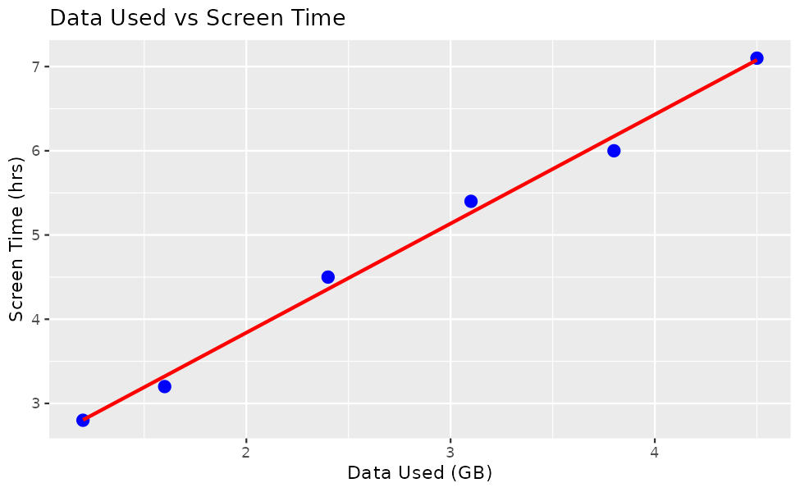
Result
The correlation between Data_Used and Screen_Time is 0.997, which is a very strong positive correlation. All the points lie very close to the trend line.
This shows that users who spend more time on the screen also consume more mobile data. For example, the user with 7.1 hours of screen time used 4.5 GB, while the user with 2.8 hours used only 1.2 GB.\

Question 3: Find the Average Satisfaction for Each Gender and Create a Bar Chart
R Code
avg_sat <- aggregate(Satisfaction ~ Gender, data = mobile, FUN = mean)
avg_sat

ggplot(avg_sat, aes(x = Gender, y = Satisfaction, fill = Gender)) +
geom_bar(stat = "identity", width = 0.5) +
geom_text(aes(label = round(Satisfaction, 2)), vjust = -0.5) +
ylim(0, 6) +
labs(
title = "Average Satisfaction by Gender",
x = "Gender",
y = "Average Satisfaction"
)
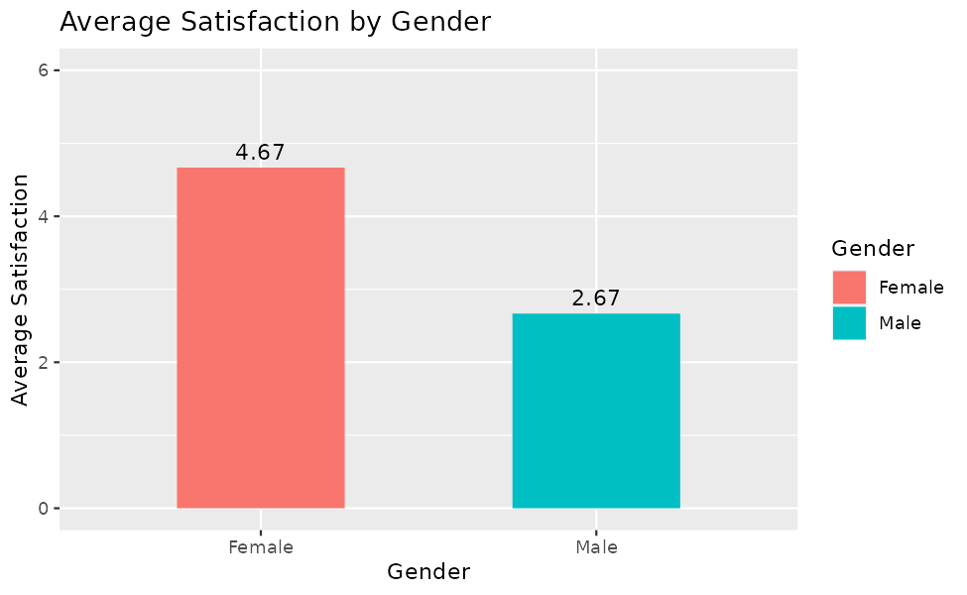
Result
The average satisfaction score is 4.67 for female users and 2.67 for male users.
Female users are more satisfied with the apps than male users. In this dataset the female users also have higher screen time and data usage, which suggests that the more the apps are used, the higher the satisfaction.

Question 4: Create a Mini Dashboard in Tableau
Procedure (Tableau)
Step 1: Connect Mobile_App_Usage.csv to Tableau using Connect > Text file.
Step 2: Create the bubble chart sheet: drag Screen_Time to Columns and Data_Used to Rows. Drag User_ID to Detail, Gender to Color, and App_Usage_Count to Size, and set the mark type to Circle.
Step 3: Create the line chart sheet: right-click Usage_Date and drag it to Columns as a continuous Month, and drag App_Usage_Count to Rows (SUM) to show the usage trend.
Step 4: Drag Gender and Usage_Date to the Filters shelf, select Show Filter for each, and choose Apply to Worksheets > All Using This Data Source.
Step 5: Create a new dashboard, drag both sheets onto it, add the filters, and give the dashboard a title.
(Insert the Tableau dashboard screenshot here)
Result
The mini dashboard contains a bubble chart of Screen Time versus Data Used, coloured by Gender and sized by App Usage Count, together with a line chart of usage trends and filters for Gender and Usage_Date.
The bubble chart shows that female users form the larger bubbles at the upper right, with high screen time, high data usage, and high app usage counts. The line chart shows that the total app usage count is 43 in January, 42 in February, and 32 in March, which indicates a gradual decline in usage over the three months.

